

**Lab 3.2.1.9 – Configuring Basic RIPv2**

## Topology

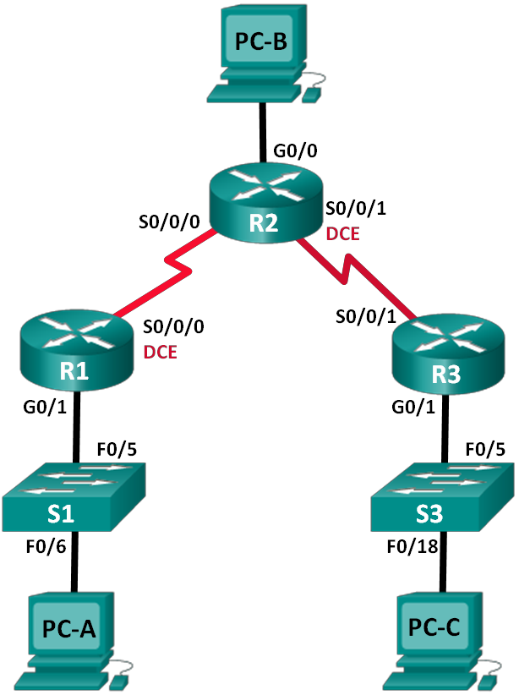

**Objectives**

**Part 1: Build the Network and Configure Basic Device Settings**

**Part 2: Configure and Verify RIPv2 Routing**

* Configure RIPv2 on the routers and verify that it is running.
* Configure a passive interface.
* Examine routing tables.
* Disable automatic summarization.
* Configure a default route.
* Verify end-to-end connectivity.

**Addressing Table**

|  |  |  |  |  |
| --- | --- | --- | --- | --- |
| **Device** | **Interface** | **IP Address** | **Subnet Mask** | **Default Gateway** |
| R1 | G0/1 | 172.30.10.1 | 255.255.255.0 | N/A |
|  | S0/0/0 (DCE) | 10.1.1.1 | 255.255.255.252 | N/A |
| R2 | G0/0 | 209.165.201.1 | 255.255.255.0 | N/A |
|  | S0/0/0 | 10.1.1.2 | 255.255.255.252 | N/A |
|  | S0/0/1 (DCE) | 10.2.2.2 | 255.255.255.252 | N/A |
| R3 | G0/1 | 172.30.30.1 | 255.255.255.0 | N/A |
|  | S0/0/1 | 10.2.2.1 | 255.255.255.252 | N/A |
| S1 | N/A | VLAN 1 | N/A | N/A |
| S3 | N/A | VLAN 1 | N/A | N/A |
| PC-A | NIC | 172.30.10.3 | 255.255.255.0 | 172.30.10.1 |
| PC-B | NIC | 209.165.201.2 | 255.255.255.0 | 209.165.201.1 |
| PC-C | NIC | 172.30.30.3 | 255.255.255.0 | 172.30.30.1 |

**Background / Scenario**

RIP version 2 (RIPv2) is used for routing of IPv4 addresses in small networks. RIPv2 is a classless, distance- vector routing protocol, as defined by RFC 1723. Because RIPv2 is a classless routing protocol, subnet masks are included in the routing updates. By default, RIPv2 automatically summarizes networks at major network boundaries. When automatic summarization has been disabled, RIPv2 no longer summarizes networks to their classful address at boundary routers.

In this lab, you will configure the network topology with RIPv2 routing, disable automatic summarization, propagate a default route, and use CLI commands to display and verify RIP routing information.

**Required Resources**

* 3 Routers (Cisco 1941 with Cisco IOS Release 15.2(4)M3 universal image or comparable)
* 2 Switches (Cisco 2960 with Cisco IOS Release 15.0(2) lanbasek9 image or comparable)
* 3 PCs (Windows 7, Vista, or XP with terminal emulation program, such as Tera Term)
* Console cables to configure the Cisco IOS devices via the console ports
* Ethernet and Serial cables as shown in the topology

**Part 1: Build the Network and Configure Basic Device Settings**

In Part 1, you will set up the network topology and configure basic settings.

**Step 1: Cable the network as shown in the topology. Step 2: Initialize and reload the router and switch.**

**Step 3: Configure basic settings for each router and switch.**

1. Disable DNS lookup.
2. Configure device names as shown in the topology.
3. Configure password encryption.
4. Assign **class** as the privileged EXEC password.
5. Assign **cisco** as the console and vty passwords.
6. Configure a MOTD banner to warn users that unauthorized access is prohibited.
7. Configure **logging synchronous** for the console line.
8. Configure the IP addresses listed in the Addressing Table for all interfaces.
9. Configure a description for each interface with an IP address.
10. Configure the clock rate **128 000**, if applicable, to the **DCE** serial interface.

**Step 4: Configure PC IP Addressing.**

Refer to the Addressing Table for IP address information of the PCs.

**Step 5: Test connectivity.**

At this point, the PCs are unable to ping each other.

1. Each workstation should be able to ping the attached router. Verify and troubleshoot if necessary.
2. The routers should be able to ping one another. Verify and troubleshoot if necessary.

|  |  |  |  |
| --- | --- | --- | --- |
| **From** | **To** | **IP Address (To)** | **Ping results** (Fail / Success) |
| **PC-A** | **R1 G0/1** | 172.30.10.1 |  |
| **PC-B** | **R2 G0/0** | 209.165.201.1 |  |
| **PC-C** | **R3 G0/1** | 172.30.30.1 |  |
| **R1** | **R2 S0/0/0** | 10.1.1.2 |  |
| **R3** | **R2 S0/0/1** | 10.2.2.2 |  |

**Part 2: Configure and Verify RIPv2 Routing**

In Part 2, you will configure RIPv2 routing on all routers in the network and then verify that the routing tables are updated correctly. After RIPv2 has been verified, you will disable automatic summarization, configure a default route, and verify end-to-end connectivity.

**Step 1: Configure RIPv2 routing.**

a. Configure **RIPv2** on **R1**as the routing protocol and advertise the appropriate connected networks.

R1# **config t**

R1(config)# **router rip**

R1(config-router)# **version 2**

R1(config-router)# **passive-interface g0/1**

R1(config-router)# **network 172.30.0.0**

R1(config-router)# **network 10.0.0.0**

The **passive-interface** command stops routing updates out the specified interface. This process prevents unnecessary routing traffic on the LAN. However, the network that the specified interface belongs to is still advertised in routing updates that are sent out across other interfaces.

1. Configure **RIPv2** on **R3** and use the **network** statement to add the appropriate connected networks and prevent routing updates on the LAN interface.
2. Configure **RIPv2** on **R2** and use the network statements to add the appropriate connected networks. **Do not advertise the 209.165.201.0 network.**   
   No anuncie o no configure la red 209.165.201.0 como directamente conectada.

**Note**: It is not necessary to make the **G0/0** interface passive on **R2** because the network associated with this interface is not being advertised.

No es necesario hacer que la interfaz G0 / 0 sea pasiva en R2 porque la red asociada con esta interfaz no se anuncia.

**Step 2: Examine the current state of the network.**

* 1. The status of the two serial links can quickly be verified using the **show ip interface brief** command on R2.

#### R2# show ip interface brief

Interface IP-Address OK? Method Status Protocol Embedded-Service-Engine0/0 unassigned YES unset administratively down down GigabitEthernet0/0 209.165.201.1 YES manual up up GigabitEthernet0/1 unassigned YES unset administratively down down Serial0/0/0 10.1.1.2 YES manual up up

Serial0/0/1 10.2.2.2 YES manual up up

b. Check connectivity between PCs.

|  |
| --- |
| From PC-A, is it possible to ping PC-B? Why? |
| NO ES POSIBLE, ya que en el R2 no está configurada en RIP la red donde está la PC-B. |
| From PC-A, is it possible to ping PC-C? _________ Why?  ____________________________________________________________________________________  No, porque el R2 tiene incorrectamente dos rutas de equilibrio de carga de igual costo (equal cost load balancing) a la subred 172.30.0.0/16.  From PC-C, is it possible to ping PC-B? Why? |
| NO ES POSIBLE, ya que en el R2 no está configurada en RIP la red donde está la PC-B. |
| From PC-C, is it possible to ping PC-A? Why? |
| No, porque el R2 tiene incorrectamente dos rutas de equilibrio de carga de igual costo (equal cost load balancing) a la subred 172.30.0.0/16. |

1. Verify that RIPv2 is running on the routers.

You can use the **debug ip rip**, **show ip protocols**, and **show run** commands to confirm that RIPv2 is running. The **show ip protocols** command output for R1 is shown below.

#### R1# show ip protocols

Routing Protocol is "rip"

Outgoing update filter list for all interfaces is not set Incoming update filter list for all interfaces is not set Sending updates every 30 seconds, next due in 7 seconds Invalid after 180 seconds, hold down 180, flushed after 240 Redistributing: rip

Default version control: send version 2, receive 2

Interface Send Recv Triggered RIP Key-chain

Serial0/0/0 2 2

Automatic network summarization is in effect Maximum path: 4

Routing for Networks: 10.0.0.0

172.30.0.0

Passive Interface(s): GigabitEthernet0/1

Routing Information Sources:

|  |  |  |
| --- | --- | --- |
| Gateway | Distance | Last Update |
| 10.1.1.2 | 120 |  |

Distance: (default is 120)

|  |
| --- |
| When issuing the **debug ip rip** command on R2, what information is provided that confirms RIPv2 is running? |
| RIP: sending v2 updates to 224.0.0.9 via Serial 0/0/0 (10.1.1.2). |
| When you are finished observing the debugging outputs, issue the **undebug all** command at the privileged EXEC prompt.  When issuing the **show run** command on R3, what information is provided that confirms RIPv2 is running? |
|  |
|  |
| router rip  version 2 |

1. Examine the automatic summarization of routes.

The LANs connected to R1 and R3 are composed of discontiguous networks. R2 displays two equal-cost paths to the 172.30.0.0/16 network in the routing table. R2 displays only the major classful network address of 172.30.0.0 and does not display any of the subnets for this network.

R2# **show ip route**

<Output omitted>

10.0.0.0/8 is variably subnetted, 4 subnets, 2 masks C 10.1.1.0/30 is directly connected, Serial0/0/0

L 10.1.1.2/32 is directly connected, Serial0/0/0 C 10.2.2.0/30 is directly connected, Serial0/0/1 L 10.2.2.2/32 is directly connected, Serial0/0/1

R 172.30.0.0/16 [120/1] via 10.2.2.1, 00:00:23, Serial0/0/1

[120/1] via 10.1.1.1, 00:00:09, Serial0/0/0

209.165.201.0/24 is variably subnetted, 2 subnets, 2 masks

C 209.165.201.0/24 is directly connected, GigabitEthernet0/0 L 209.165.201.1/32 is directly connected, GigabitEthernet0/0

R1 displays only its own subnet for the 172.30.10.0/24 network. R1 does not have a route for the 172.30.30.0/24 subnet on R3.

R1# **show ip route**

<Output omitted>

10.0.0.0/8 is variably subnetted, 3 subnets, 2 masks C 10.1.1.0/30 is directly connected, Serial0/0/0

L 10.1.1.1/32 is directly connected, Serial0/0/0

R 10.2.2.0/30 [120/1] via 10.1.1.2, 00:00:21, Serial0/0/0

172.30.0.0/16 is variably subnetted, 2 subnets, 2 masks

C 172.30.10.0/24 is directly connected, GigabitEthernet0/1 L 172.30.10.1/32 is directly connected, GigabitEthernet0/1

R3 only displays its own subnet for the **172.30.30.0/24** network. R3 does not have a route for the 172.30.10.0/24 subnets on R1.

R3# **show ip route**

<Output omitted>

10.0.0.0/8 is variably subnetted, 3 subnets, 2 masks C 10.2.2.0/30 is directly connected, Serial0/0/1

L 10.2.2.1/32 is directly connected, Serial0/0/1

R 10.1.1.0/30 [120/1] via 10.2.2.2, 00:00:23, Serial0/0/1

172.30.0.0/16 is variably subnetted, 2 subnets, 2 masks

C 172.30.30.0/24 is directly connected, GigabitEthernet0/1 L 172.30.30.1/32 is directly connected, GigabitEthernet0/1

Use the **debug ip rip** command on **R2** to determine the routes received in the RIP updates from **R3** and list them here.

R2#unRIP: received v2 update from 10.2.2.1 on Serial0/0/1

__________________________________________________________________________________

R3 is not sending any of the **172.30.0.0** subnets, only the summarized route of **172.30.0.0/16**, including

the subnet mask. Therefore, the routing tables on R1 and R2 do not display the **172.30.0.0** subnets on R3.



**Step 3: Disable automatic summarization.**

a. The **no auto-summary** command is used to turn off automatic summarization in RIPv2. Disable auto summarization on all routers. The routers will no longer summarize routes at major classful network boundaries. R1 is shown here as an example.

R1(config)# **router rip**

R1(config-router)# **no auto-summary**

b. Issue the **clear ip route \*** command to clear the routing table. **To be effective, execute this command at least three times.**

R1(config-router)# **end**

R1# **clear ip route \***

c. Examine the routing tables. Remember that it will take some time to converge the routing tables after clearing them.

The LAN subnets connected to R1 and R3 should now be included in all three routing tables.

R2# **show ip route**

<Output omitted>

Gateway of last resort is not set

10.0.0.0/8 is variably subnetted, 4 subnets, 2 masks

C 10.1.1.0/30 is directly connected, Serial0/0/0 L 10.1.1.2/32 is directly connected, Serial0/0/0 C 10.2.2.0/30 is directly connected, Serial0/0/1 L 10.2.2.2/32 is directly connected, Serial0/0/1

172.30.0.0/16 is variably subnetted, 3 subnets, 2 masks

R 172.30.0.0/16 [120/1] via 10.2.2.1, 00:01:01, Serial0/0/1

[120/1] via 10.1.1.1, 00:01:15, Serial0/0/0 R 172.30.10.0/24 [120/1] via 10.1.1.1, 00:00:21, Serial0/0/0 R 172.30.30.0/24 [120/1] via 10.2.2.1, 00:00:04, Serial0/0/1

209.165.201.0/24 is variably subnetted, 2 subnets, 2 masks

C 209.165.201.0/24 is directly connected, GigabitEthernet0/0 L 209.165.201.1/32 is directly connected, GigabitEthernet0/0 R1# **show ip route**

<Output omitted>

Gateway of last resort is not set

10.0.0.0/8 is variably subnetted, 3 subnets, 2 masks C 10.1.1.0/30 is directly connected, Serial0/0/0

L 10.1.1.1/32 is directly connected, Serial0/0/0

R 10.2.2.0/30 [120/1] via 10.1.1.2, 00:00:12, Serial0/0/0

172.30.0.0/16 is variably subnetted, 3 subnets, 2 masks

C 172.30.10.0/24 is directly connected, GigabitEthernet0/1 L 172.30.10.1/32 is directly connected, GigabitEthernet0/1

R 172.30.30.0/24 [120/2] via 10.1.1.2, 00:00:12, Serial0/0/0

R3# **show ip route**

<Output omitted>

10.0.0.0/8 is variably subnetted, 3 subnets, 2 masks C 10.2.2.0/30 is directly connected, Serial0/0/1

L 10.2.2.1/32 is directly connected, Serial0/0/1

R 10.1.1.0/30 [120/1] via 10.2.2.2, 00:00:23, Serial0/0/1

172.30.0.0/16 is variably subnetted, 2 subnets, 2 masks

C 172.30.30.0/24 is directly connected, GigabitEthernet0/1 L 172.30.30.1/32 is directly connected, GigabitEthernet0/1 R 172.30.10.0 [120/2] via 10.2.2.2, 00:00:16, Serial0/0/1

d. Use the **debug ip rip** command on R2 to examine the RIP updates.

|  |  |
| --- | --- |
| **R2# debug ip rip**  After 60 seconds, issue the **no debug ip rip** command.  What routes are in the RIP updates that are received from R3?  R2#unRIP: received v2 update from 10.2.2.1 on Serial0/0/1 |  |
| Are the subnet masks included in the routing updates? |



**Step 4: Configure and redistribute a default route for Internet access.**

a. From R2, create a static route to network 0.0.0.0 0.0.0.0, using the **ip route** command. This forwards any traffic with an unknown destination address to PC-B at 209.165.201.2, simulating the Internet by setting a Gateway of Last Resort on router R2.

R2(config)# **ip route 0.0.0.0 0.0.0.0 209.165.201.2**

b. R2 will advertise a route to the other routers if the **default-information originate** command is added to its RIP configuration.

R2(config)# **router rip**

R2(config-router)# **default-information originate**

### Step 5: Verify the routing configuration.

1. View the routing table on R1.

R1# **show ip route**

<Output omitted>

Gateway of last resort is 10.1.1.2 to network 0.0.0.0

R* 0.0.0.0/0 [120/1] via 10.1.1.2, 00:00:13, Serial0/0/0

10.0.0.0/8 is variably subnetted, 3 subnets, 2 masks C 10.1.1.0/30 is directly connected, Serial0/0/0

L 10.1.1.1/32 is directly connected, Serial0/0/0

R 10.2.2.0/30 [120/1] via 10.1.1.2, 00:00:13, Serial0/0/0

172.30.0.0/16 is variably subnetted, 3 subnets, 2 masks

C 172.30.10.0/24 is directly connected, GigabitEthernet0/1 L 172.30.10.1/32 is directly connected, GigabitEthernet0/1

R 172.30.30.0/24 [120/2] via 10.1.1.2, 00:00:13, Serial0/0/0

How can you tell from the routing table that the subnetted network shared by R1 and R3 has a pathway for Internet traffic?

**¿Cómo puede saber la tabla de enrutamiento que la red dividida en subredes compartida por R1 y R3 tiene una ruta para el tráfico de Internet?**

**There is a Gateway of Last Resort, and the default route shows up in the table as being learned via RIP.**

**Hay una puerta de enlace de último recurso y la ruta predeterminada aparece en la tabla como aprendida a través de RIP.**

1. View the routing table on **R2**.

How is the pathway for Internet traffic provided in its routing table?

**¿Cómo se proporciona la ruta para el tráfico de Internet en su tabla de enrutamiento?**

**R2 has a default static route to 0.0.0.0 via 209.165.201.2, which is directly connected to G0/0.**

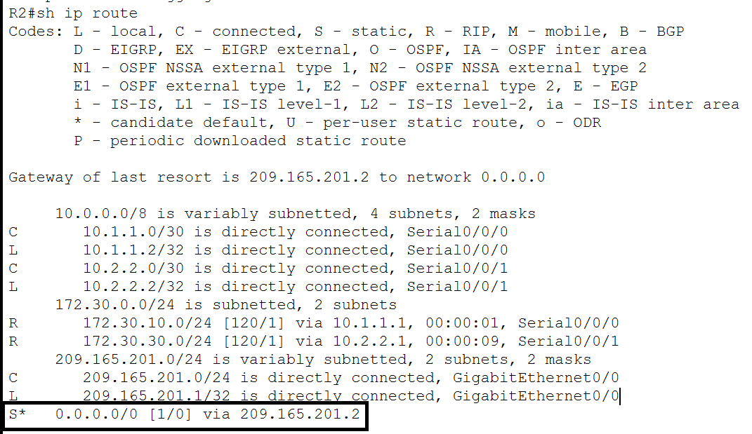

**Step 6: Verify connectivity.**

a. Simulate sending traffic to the Internet by pinging from PC-A and PC-C to 209.165.201.2.

Were the pings successful?

b. Verify that hosts within the subnetted network can reach each other by pinging between PC-A and PC-C.

Were the pings successful?

**Note**: It may be necessary to disable the PCs firewall.

**Reflection**

1. Why would you turn off automatic summarization for RIPv2?

**¿Por qué desactivar la sumarización automática para RIPv2?**

**Para que los routers no resuman las rutas a su dirección de red de clase.**

2. How did R1 and R3 learn the pathway to the Internet?

¿Cómo aprendieron R1 y R3 el camino hacia Internet?

**De las actualizaciones de enrutamiento RIP recibidas del ruteador donde se configuró la ruta por default (R2).**

En este Laboratorio estaremos trabajando con la instalación y configuración del protocolo de ruteo dinámico RIP v2.

El objetivo es que todos los dispositivos puedan conectarse.

PCA – PC-C

PCA – PC-B

Etc

Cada red o subred pertenecen a una clase.

**172.30.10.0** y **172.30.30.0** son redes clase B subneteadas.

Estas subredes no son contiguas, las subredes están desagrupadas, está el router 2 entre estas dos subredes.

Pertenecen a la misma clase de red.

La clase para estas dos subredes es la misma **172.30.0.0**

El protocolo de ruteo rip cada **30 segundos** intercambia información de sus tablas de ruteo con sus vecinos.

El router 1 le dice al router 2, yo conozco como llegar a la subred **172.30.10.0**

El router 3 le dice al router 2, yo conozco como llegar a la subred **172.30.30.0**

En ese momento el router 2 entra en conflicto, ya que puede llegar a la red **172.30.0.0** por dos rutas distintas y la red no se puede alcanzar.

Una red que se encuentra desagrupada o fragmentada como esta, tengo que desactivar el comando **autosummary** en todos los routers.

El activar el comando **no autosummary** en rip v 2 les permite trabajar con redes fragmentadas o desagrupadas, separadas por un router. **Vamos a trabajar con subredes no las summarizes** a su dirección de red o de clase.

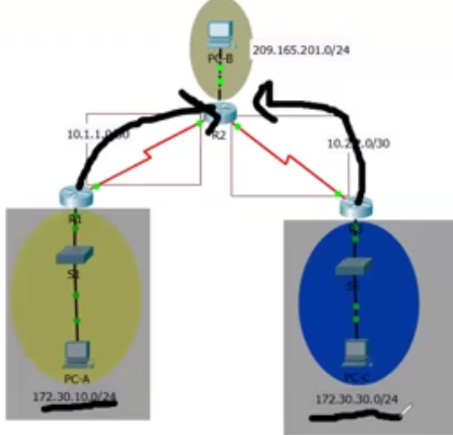

Vamos a hacer pings a nuestros gateways desde nuestro equipos y será exitoso.

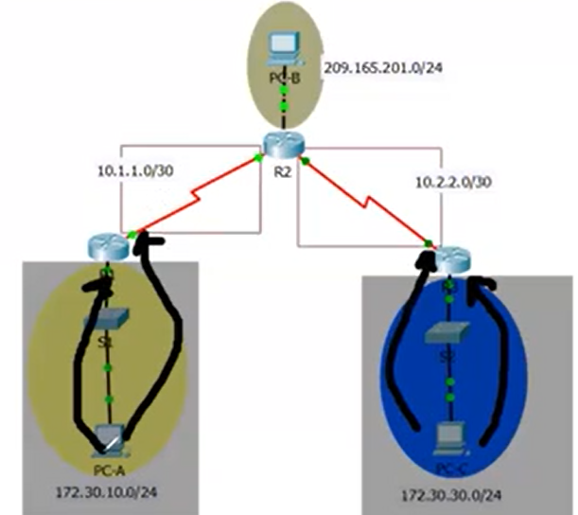

Todos los routers deben tener instalado **no auto-summary**

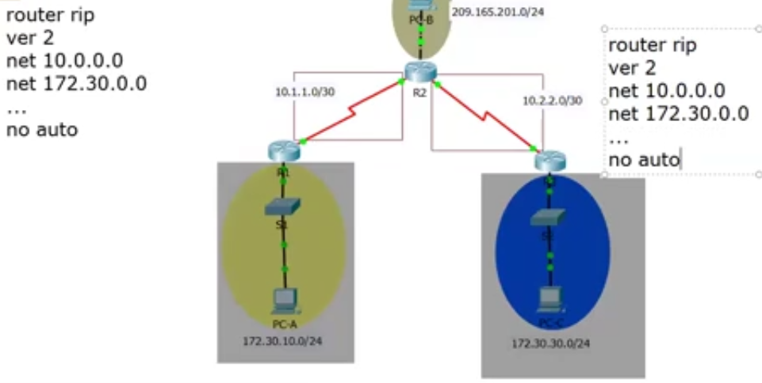

Que diferencia hay entre la configuración del router 1 y del router 3. Es la misma configuración, por lo que el **router 2 no puede conocer dos rutas distintas para llegar a la misma red.**

La dirección **10.0.0.0** no aplica esta situación ya que están directamente conectadas.

Para conocer subredes distintas a través del protocolo RIP v2 tengo que habilitar **no auto-summary**

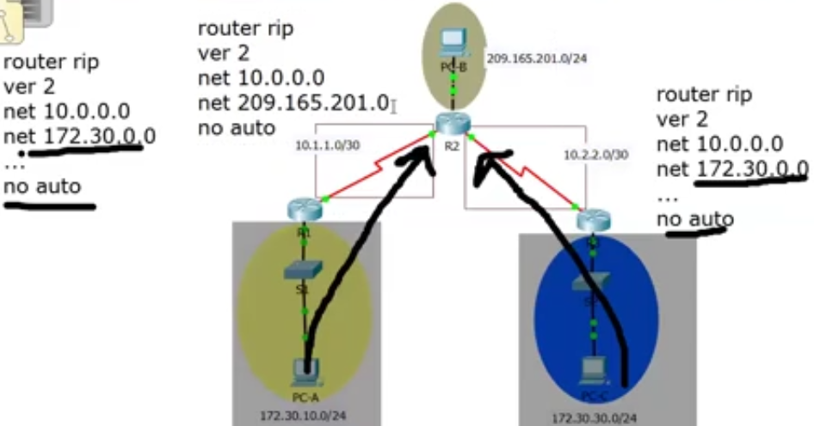

Router rip solamente configura redes directamente conectadas.

Si **tengo un destino que puedo llegar don dos rutas distintas**, hay inconsistencia en la red.

En la práctica solamente está el diseño físico de la red.

Color Amarillo lo que tengo que programar.

Color verde lo que temenos que probar.